**Figures**

**Figure 1: Overview of available gene expression data.** Our study uses a previously published dataset consisting of 155 samples [13, 14]. 152 samples have whole-transcriptome RNA-Seq reads and 105 have mass-spec proteomics reads. 102 of the 155 samples have both mRNA and protein reads. Bacteria were grown on four different carbon sources (glucose, glycerol, gluconate, and lactate), two sodium concentrations (base and high), and three magnesium concentrations (low, base, and high). Samples were taken at multiple time points during a two-week interval, and they can be broadly subdivided into exponential phase, stationary phase, and late stationary phase samples.

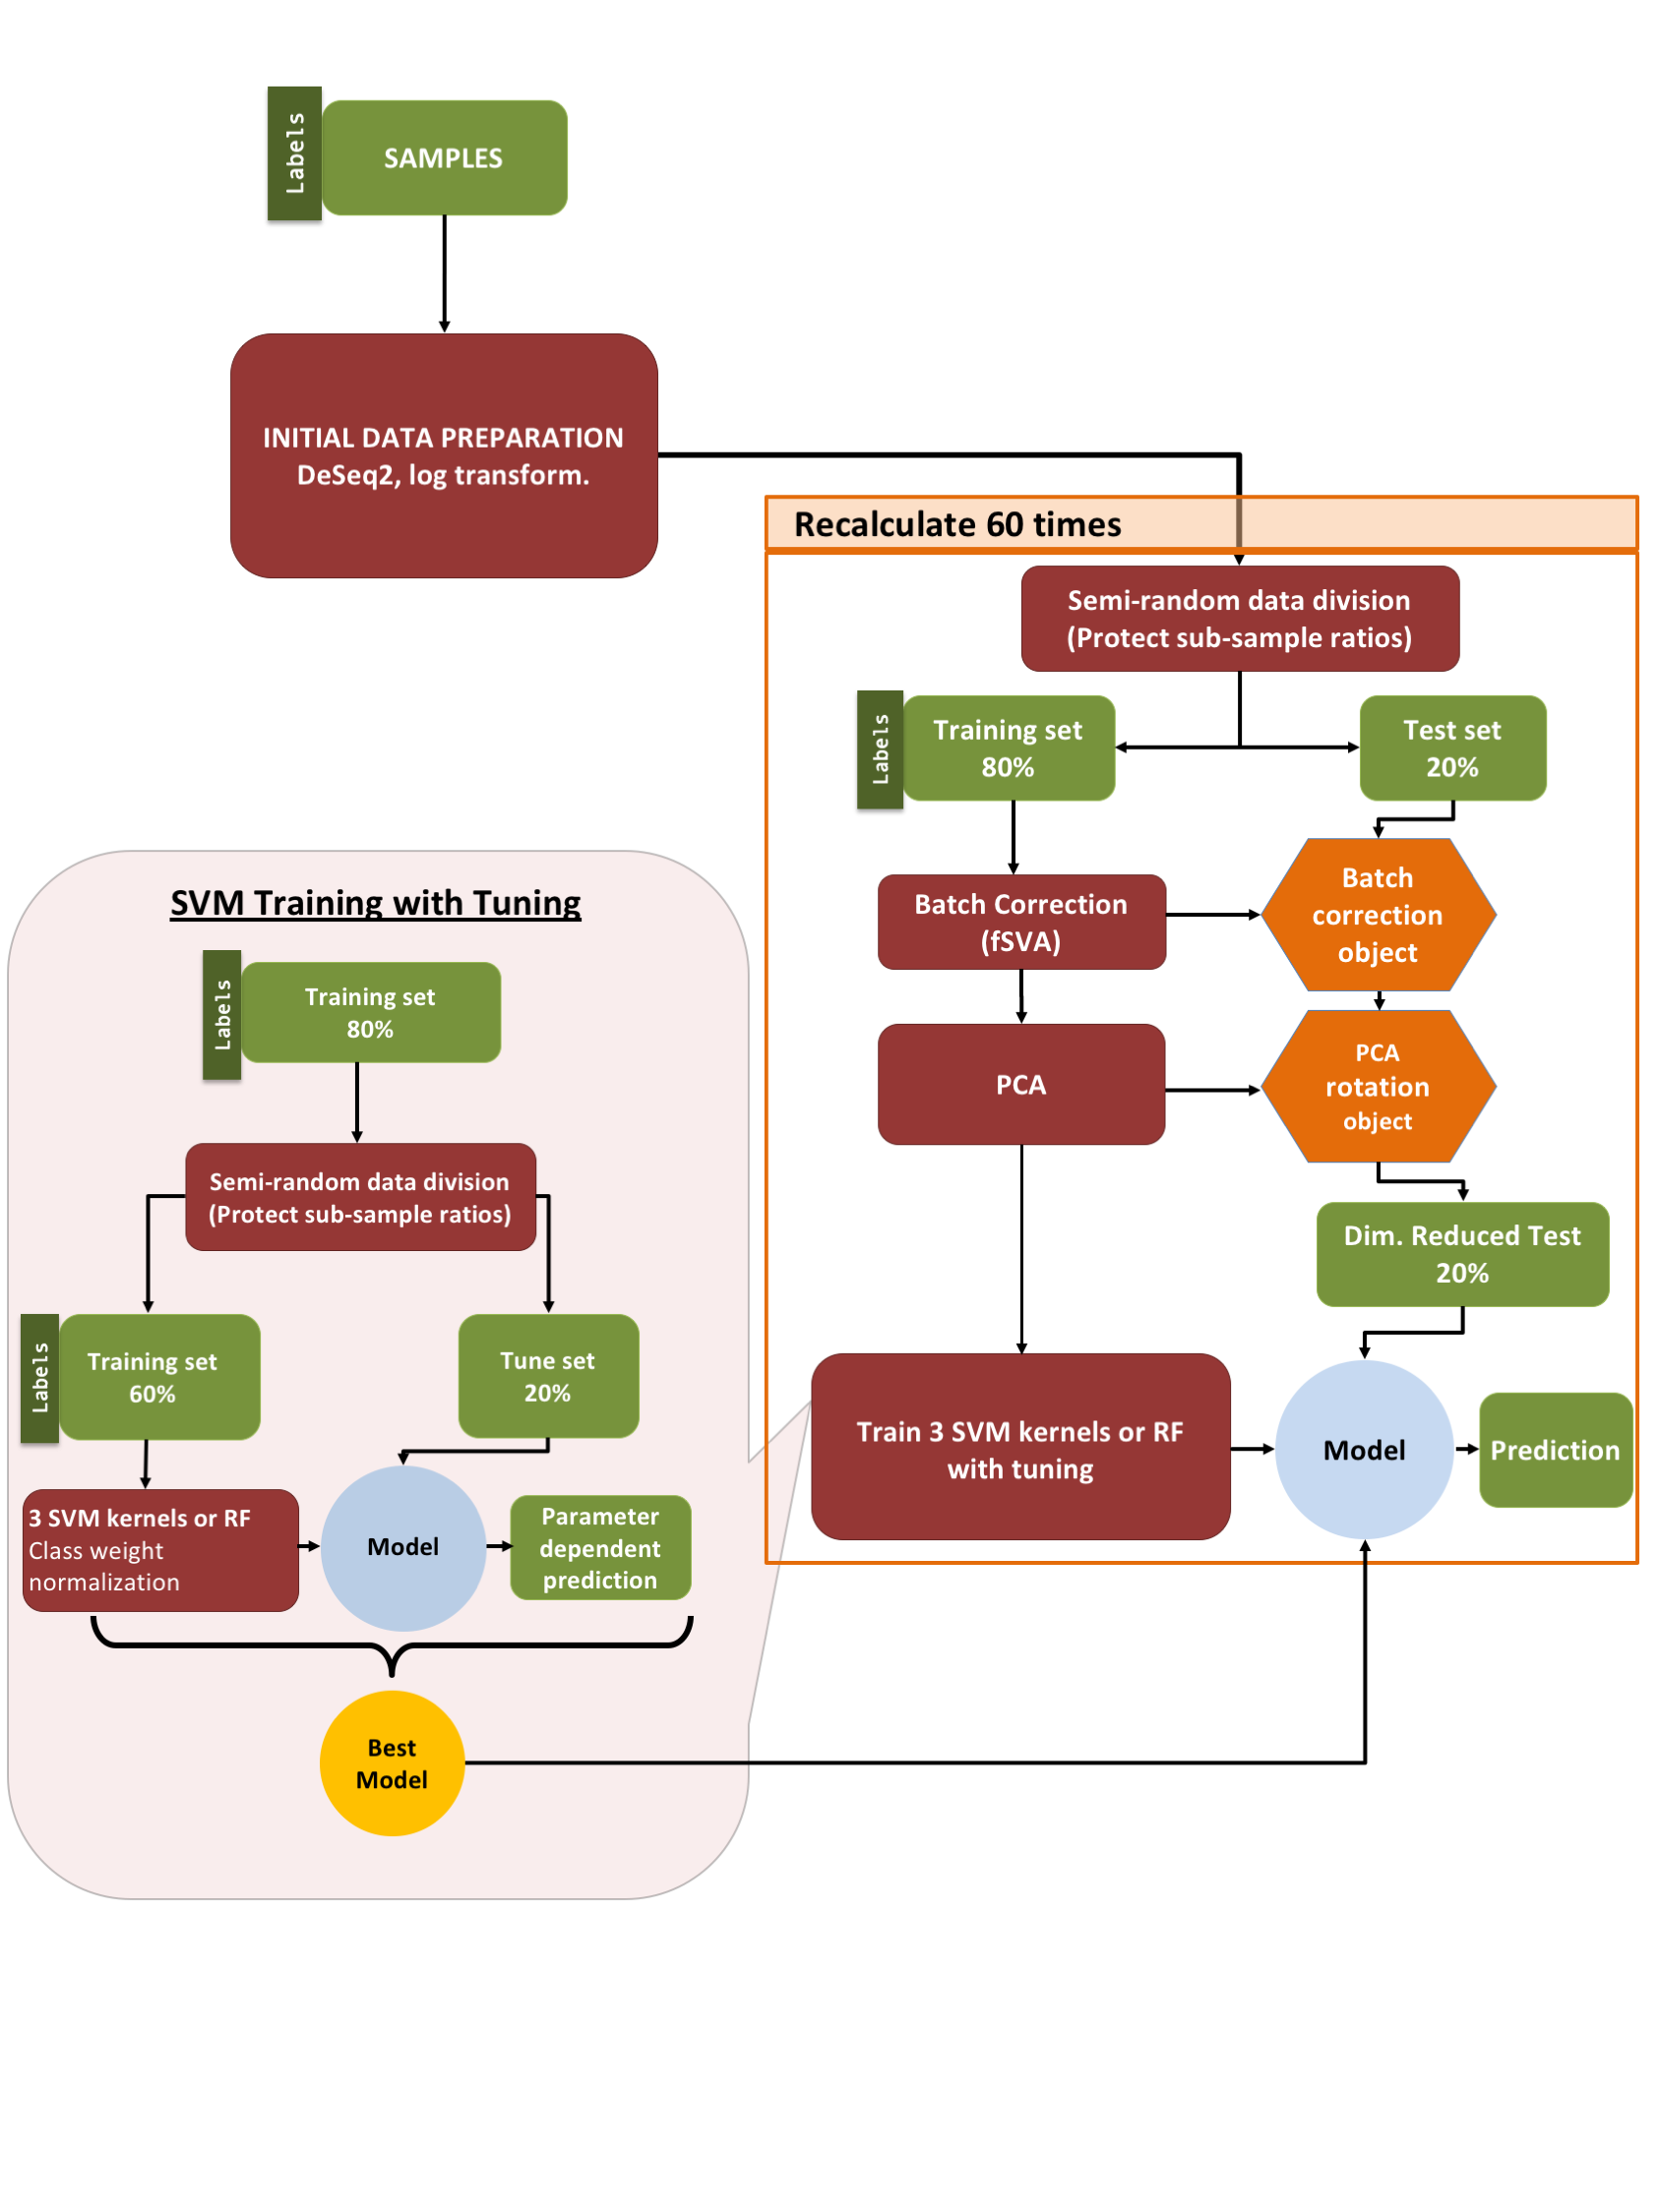

**Figure 2: Machine learning pipeline.** Our pipeline can be separated into three parts: (i) initial data preparation, (ii) training and prediction, and (iii) model tuning. After (i) initial data preparation, the samples are (ii) semi-randomly (preserving sub-sample ratios) separated into 2 parts, the training & tune set and the test set. After applying fSVA and PCA to the training data, train supervised SVM or random forest models via tuning. After obtaining the tuned model we make predictions on the test data that has been batch corrected (via fSVA) and rotated (via PCA). This whole process is repeated 60 times to collect statistics on model performance. For model tuning (iii), the training & tune data set is similarly divided semi-randomly into training and tune datasets. The tuning procedure is repeated 10 times and the model that performs best on average during the 10 repeats is considered the winning model and is used for prediction on the test data.

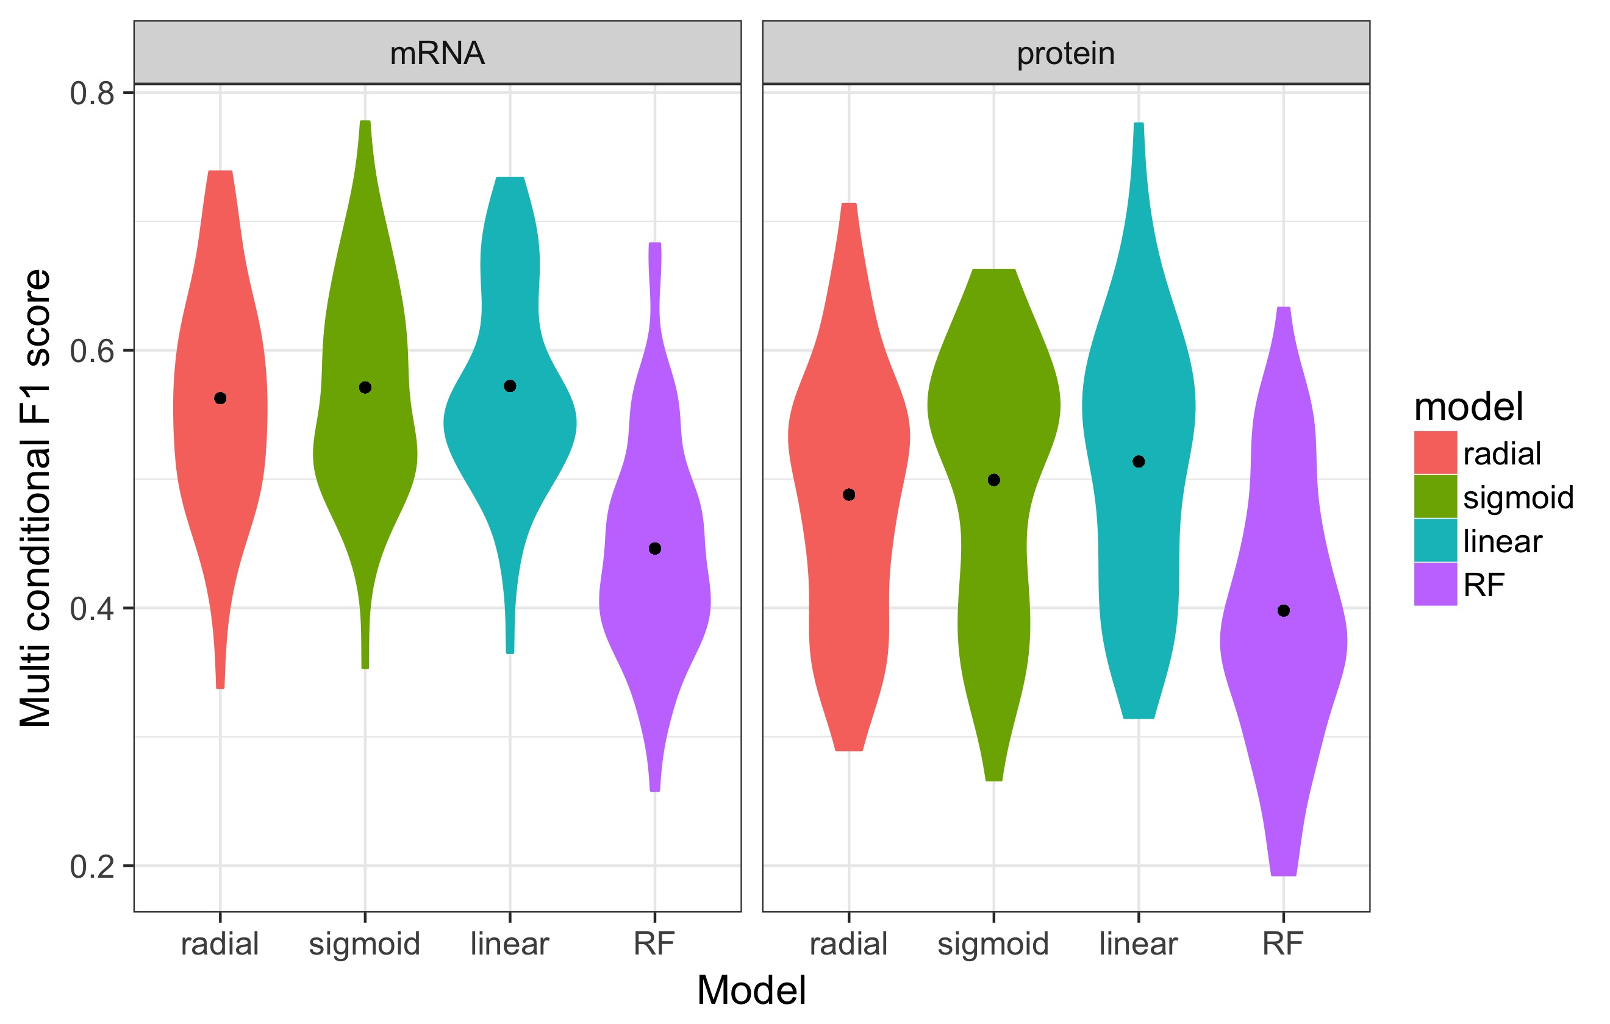

**Figure 3: Performance of multi-conditional predictions.** Distributions of multi conditional *F1* scores for prediction of growth conditions from mRNA or protein abundances, using four different machine-learning algorithms (SVM with radial, sigmoidal, or linear kernel, and random forest [RF] models). For each model type, 60 independent models were trained on 60 independent subdivisions of the data into training and test sets. We found that random forest models consistently performed worse than SVM models, and predictions based on mRNA data were slightly better than predictions based on protein data. The black dots represent the mean *F1* scores.

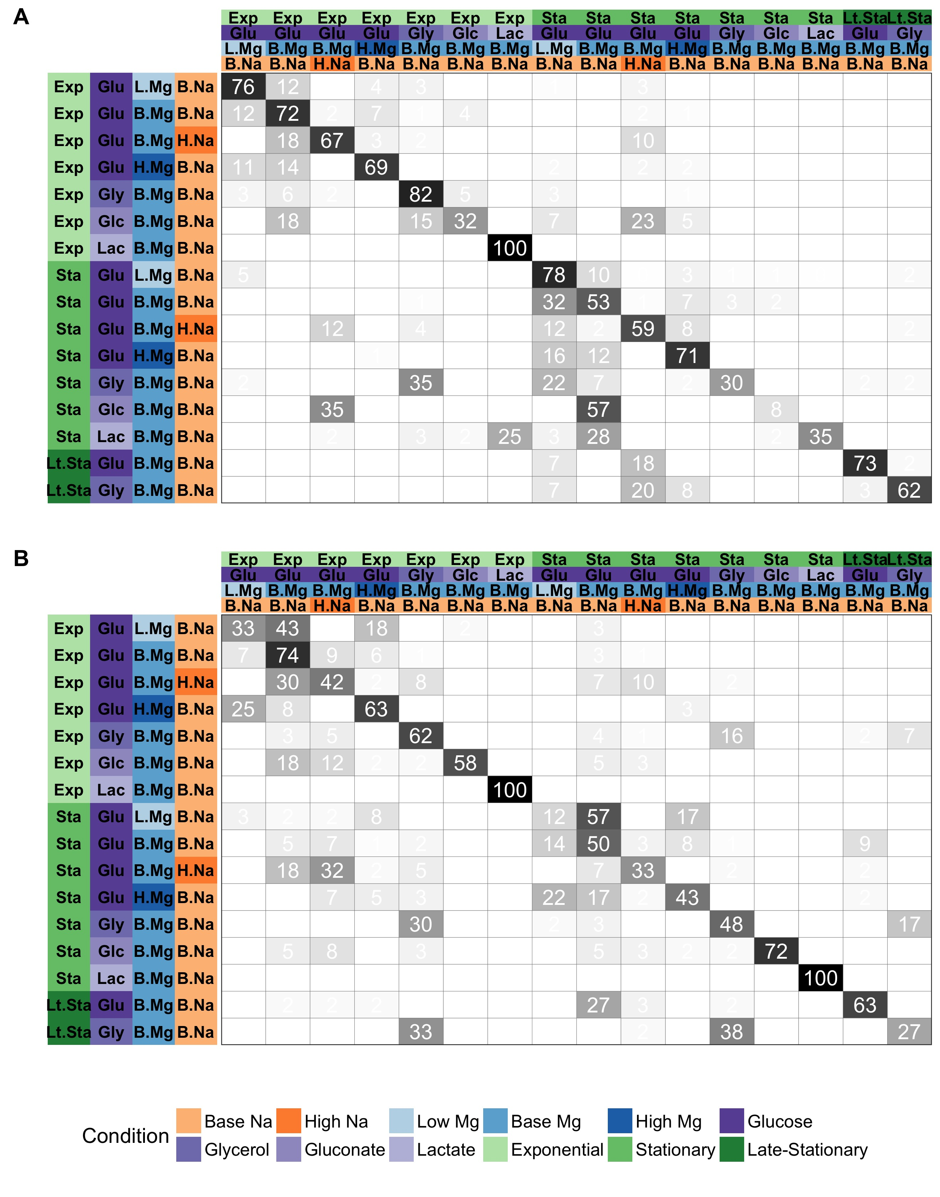

**Figure 4. Prediction accuracy for specific growth conditions.** In each matrix, rows represent true conditions and columns represent predicted conditions. The numbers in the cells and the shading of the cells represent the percentage (out of 60 independent replicates) with which a given true condition is predicted as a certain predicted condition. (A)Predictions based on mRNA abundances. Results are shown for the SVM with radial kernel, which was the best performing model in the tuning process on mRNA data, where it won 53 of 60 independent runs. 62.7% of the predictions fall on the diagonal line. (B)Predictions based on protein abundances. Results are shown for the SVM with sigmoidal kernel, which was the best performing model in the tuning process on protein data, where it won 38 of 60 independent runs. 54.3% of the predictions fall on the diagonal line.



**Figure 5. Models trained on both mRNA and protein data perform better than models trained on only one data type.** The 102 samples for which we have both protein and mRNA abundances were used to compare the performance of machine learning models on only mRNA, only protein, and mRNA and protein data combined (left to right facet). Regardless of the machine learning model used for prediction, prediction performance was higher on protein data than on mRNA data. It was also higher on combined data than on either mRNA or protein data alone. Statistical significance of these differences is reported in Table 2.



**Figure 6. Prediction accuracy systematically declines from exponential to stationary.** We separated data by growth phase and then trained models to predict carbon source, magnesium level, and sodium level within each growth phase. Regardless of machine-learning model data source (mRNA vs protein) used, prediction accuracy was substantially lower for stationary-phase samples than for exponential-phase samples. For each model and growth phase, dots show the mean *F*1 score over 60 replicates and lines connect mean *F*1 scores calculated for the same model.



**Figure 7. Model performance on univariate predictions.** The multi-class F1 score of tuned models over “test data”, for four individual conditions: carbon source, growth phase, Mg2+ levels, and Na+ levels. To keep mRNA-based and protein-based predictions comparable, we used the 102 samples with both mRNA and protein abundances for this analysis.

**Tables**

**Table 1: Winning-model distributions at the tuning stage.** Numbers show the number of times out of 60 independent runs that each given model had the highest *F*1 score in the tuning process. Results are shown separately for predictions on the mRNA and the protein data.

|  |  |  |
| --- | --- | --- |
|  | mRNA | Protein |
| SVM, radial kernel | 53 | 14 |
| SVM, sigmoidal kernel | 6 | 11 |
| SVM, linear kernel | 0 | 22 |
| Random Forest | 1 | 38 |

**Table 2:** **Statistical significance of comparisons shown in Figure 5.** Distributions of multi conditional *F*1 scores were compared by t tests. All comparisons are statistically significant after correction for multiple testing.

|  |  |  |  |
| --- | --- | --- | --- |
| Model | Comparison | *P* value | Adjusted  *P* value |
| SVM, radial kernel | mRNA vs protein | 1.943E-09 | 4.663E-09 |
| SVM, radial kernel | mRNA + protein vs mRNA | 3.908E-13 | 2.345E-12 |
| SVM, radial kernel | mRNA + protein vs protein | 8.425E-03 | 1.087E-02 |
| SVM, sigmoidal kernel | mRNA vs protein | 3.327E-08 | 6.654E-08 |
| SVM, sigmoidal kernel | mRNA + protein vs mRNA | 3.088E-11 | 1.235E-10 |
| SVM, sigmoidal kernel | mRNA + protein vs protein | 3.517E-02 | 3.517E-02 |
| SVM, linear kernel | mRNA vs protein | 4.728E-11 | 1.418E-10 |
| SVM, linear kernel | mRNA + protein vs mRNA | 1.595E-15 | 1.914E-14 |
| SVM, linear kernel | mRNA + protein vs protein | 9.441E-03 | 1.087E-02 |
| Random Forest | mRNA vs protein | 1.818E-03 | 2.727E-03 |
| Random Forest | mRNA + protein vs mRNA | 1.928E-07 | 3.306E-07 |
| Random Forest | mRNA + protein vs protein | 9.968E-03 | 1.087E-02 |

**Table 3. Performance of the protein model on external data.** For each of the five external samples we matched to conditions in our dataset, we show the predicted sodium level, magnesium level, carbon source, and growth phase. Black text indicates a correct prediction. Red text indicates an incorrect prediction. Blue text indicates a prediction for a condition where the external data falls between two categories in our data (see Methods for details). (A) Predictions using a model trained on our complete training dataset. Any missing protein abundances in the external test data were replaced by the median values in the training dataset. (B) Predictions using a model that was trained on the subset of proteins that was present in both training and external test data.

|  |  |  |  |  |
| --- | --- | --- | --- | --- |
| **A** |  |  |  |  |
| **Sample** | **Na level** | **Mg level** | **Carbon source** | **Growth phase** |
| A (Base sample) | base Na | high Mg | Glucose | Exponential |
| B (Glycerol sample) | base Na | high Mg | Glucose | Exponential |
| C (High Na sample) | base Na | high Mg | Glucose | Exponential |
| D (Stationary phase sample) | base Na | base Mg | Glucose | Stationary |
| E (Late stationary phase sample) | base Na | base Mg | Glucose | Stationary |
|  |  |  |  |  |
|  |  |  |  |  |
| **B** |  |  |  |  |
| **Sample** | **Na level** | **Mg level** | **Carbon source** | **Growth phase** |
| A (Base sample) | base Na | base Mg | Gluconate | Exponential |
| B (Glycerol sample) | base Na | base Mg | Gluconate | Exponential |
| C (High Na sample) | high Na | base Mg | Glucose | Exponential |
| D (Stationary phase sample) | base Na | base Mg | Glucose | Stationary |
| E (Late stationary phase sample) | base Na | base Mg | Glucose | Stationary |